Project Design Phase-II
Data Flow Diagram & User Stories

Date | 16 February 2026
Team ID | LTVIP2026TMIDS73212
Project Name | ResolveNow - Online Complaint Registration and Management System
Maximum Marks | 4 Marks

Data Flow Diagrams:
A Data Flow Diagram (DFD) represents how information flows within the ResolveNow system. It shows how users submit complaints, how administrators assign them, how agents handle them, and how data is stored in the database.
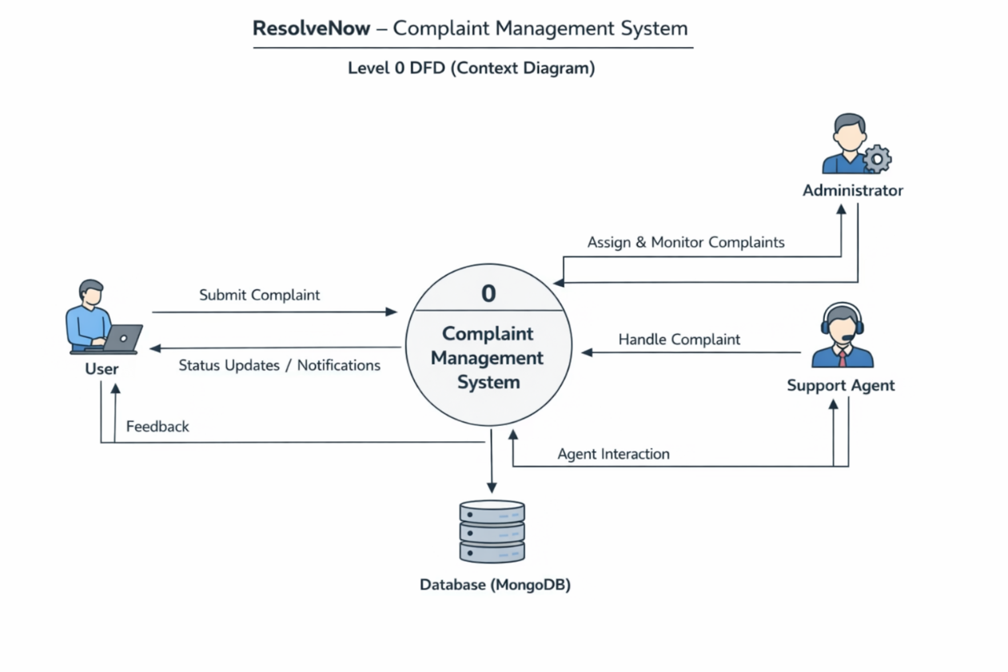

User Stories
User Type | Functional Requirement (Epic) | User Story Number | User Story / Task | Acceptance Criteria | Priority | Release
Customer (Web user) | Registration | USN-1 | As a user, I can register using name, email and password | User account created & dashboard accessible | High | Sprint-1
Customer (Web user) | Registration | USN-2 | As a user, I receive confirmation email after registration | Email received & verified successfully | High | Sprint-1
Customer (Web user) | Login | USN-3 | As a user, I can login using email & password | Successful login & dashboard access | High | Sprint-1
Customer (Web user) | Complaint Submission | USN-4 | As a user, I can submit complaint with details & attachments | Complaint ID generated & stored in database | High | Sprint-1
Customer (Web user) | Complaint Tracking | USN-5 | As a user, I can track complaint status | Status visible (Pending/In Progress/Resolved) | High | Sprint-2
Customer (Web user) | Communication | USN-6 | As a user, I can chat with assigned agent | Messages exchanged in real-time | Medium | Sprint-2
Customer (Web user) | Feedback | USN-7 | As a user, I can give feedback after resolution | Feedback stored successfully | Medium | Sprint-3
Customer Care Executive | Complaint Handling | USN-8 | As an agent, I can view assigned complaints | Assigned complaints displayed in dashboard | High | Sprint-1
Customer Care Executive | Status Update | USN-9 | As an agent, I can update complaint status | Status updated & user notified | High | Sprint-2
Administrator | Complaint Assignment | USN-10 | As admin, I can assign complaints to agents | Complaint assigned successfully | High | Sprint-1
Administrator | Monitoring | USN-11 | As admin, I can monitor all complaints | All complaints visible in dashboard | High | Sprint-2

